1. **Create one IAM user and assign ec2,s3 full access role.**

**IAM ---> Users --->** click **create user**

Enter **np** as username

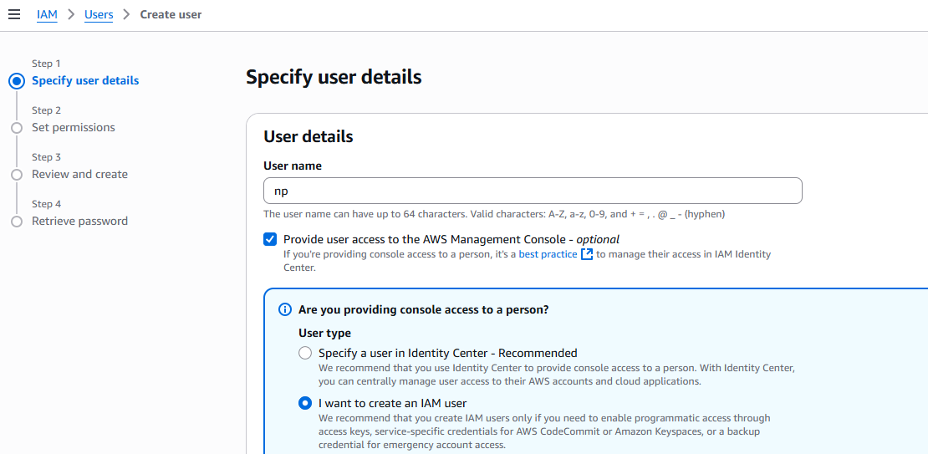

Select **Attach policies directly** in permission options

Attach **AmazonEc2FullAccess** and **AmazonS3FullAccess in** permission policies.

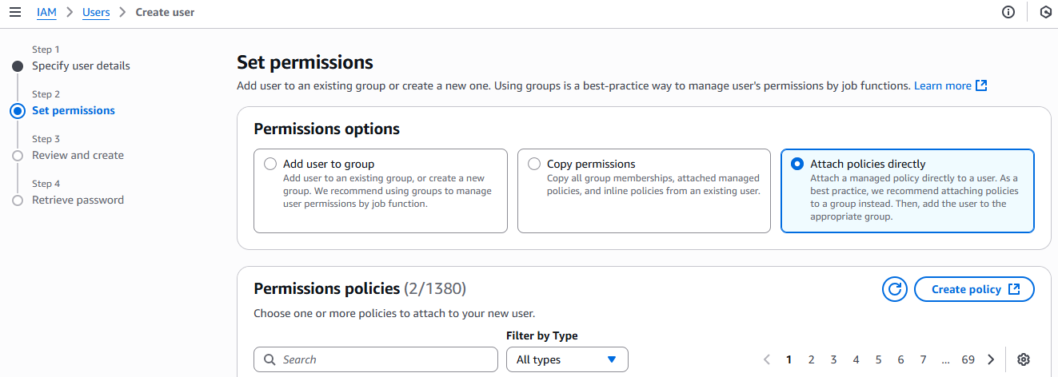

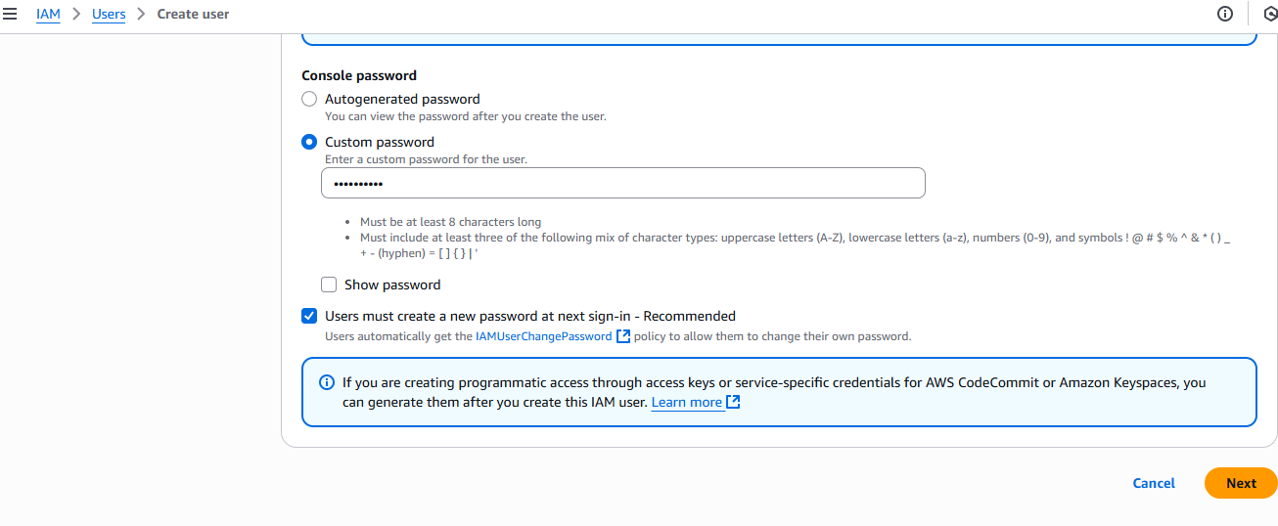

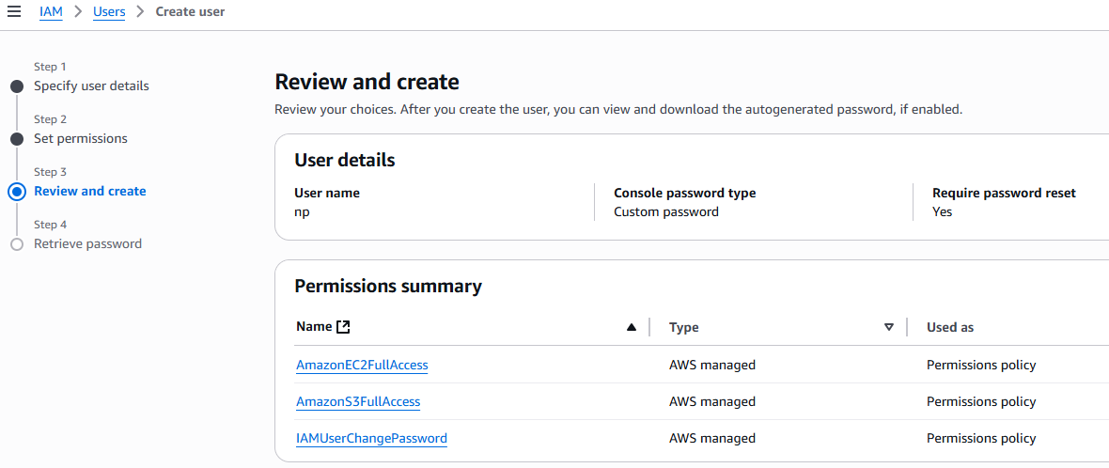

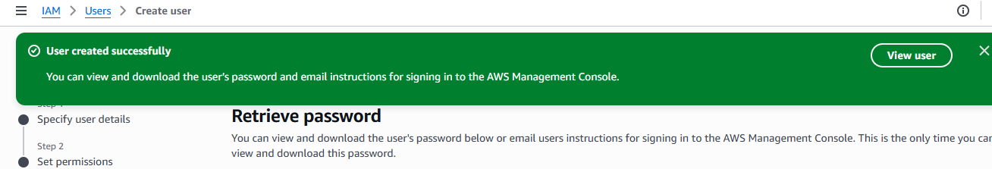

To check created **IAM User** login in aws console in IAM user

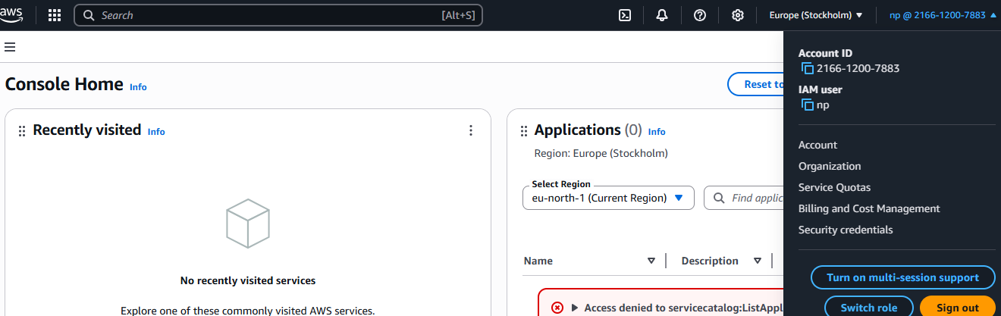

1. **Create one Group in IAM and Assign Read access for ec2.**

**IAM ---> User groups --->** click user group

Enter **techie** as user group name

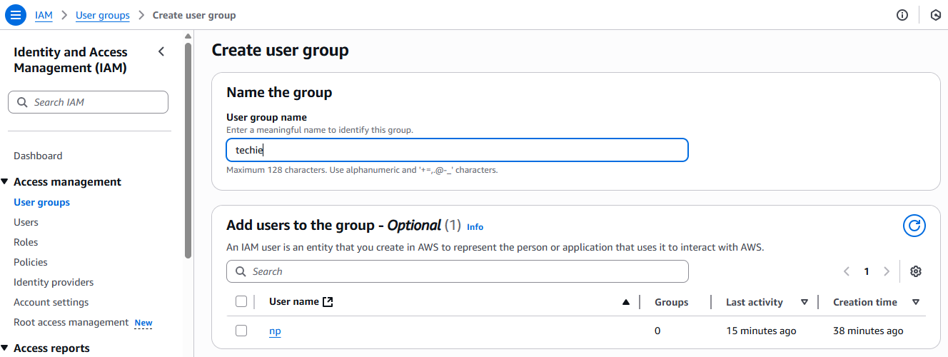

Attach **AmazonEC2ReadOnlyAccess** in permissions policies.

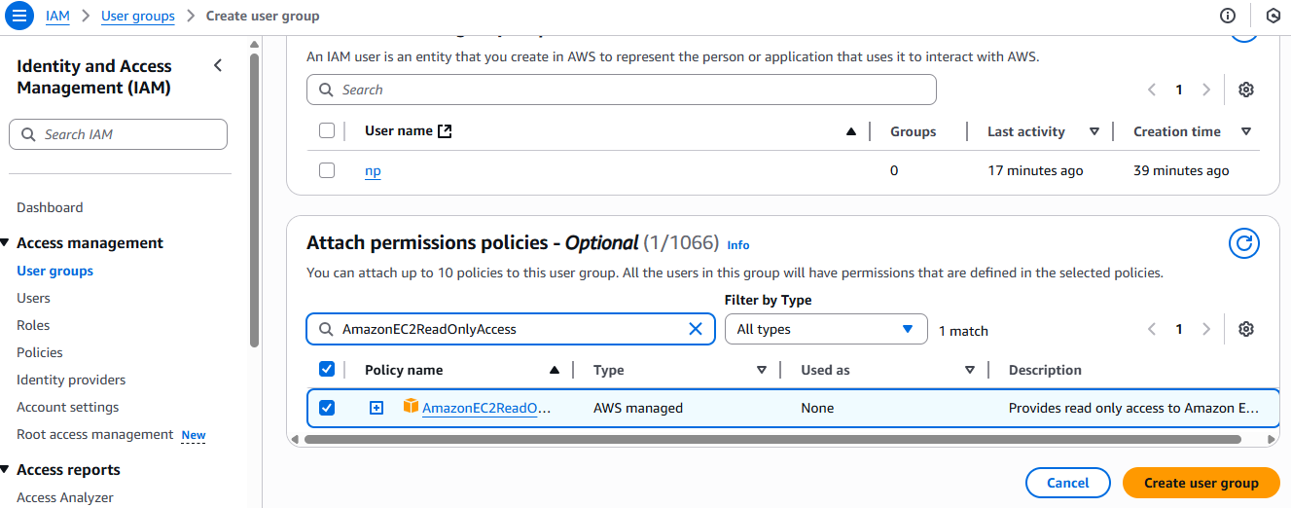

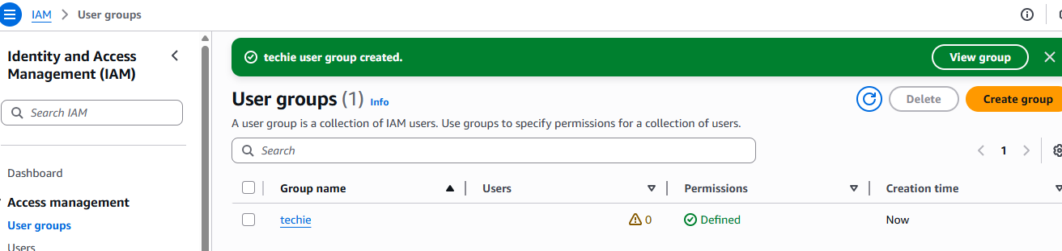

1. **Create a new user with name Devops and add to the group created in task2.**

**IAM ---> Users --->** click **create user**

Enter **Devops** as username

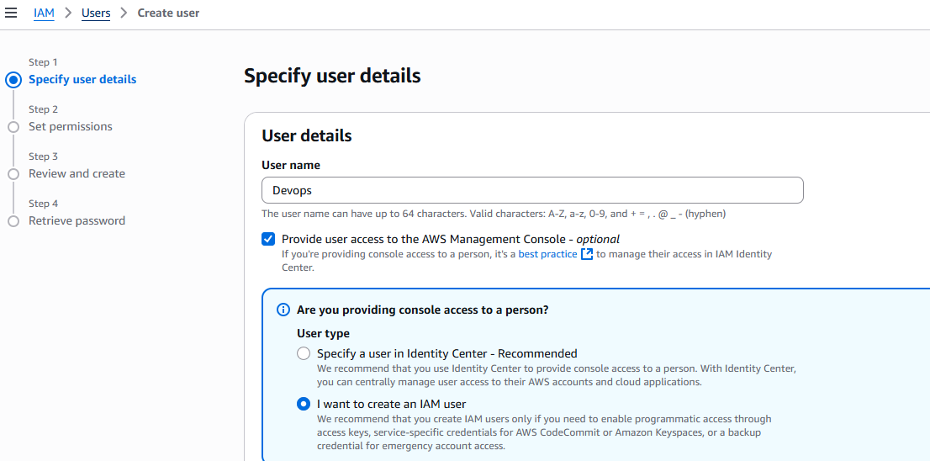

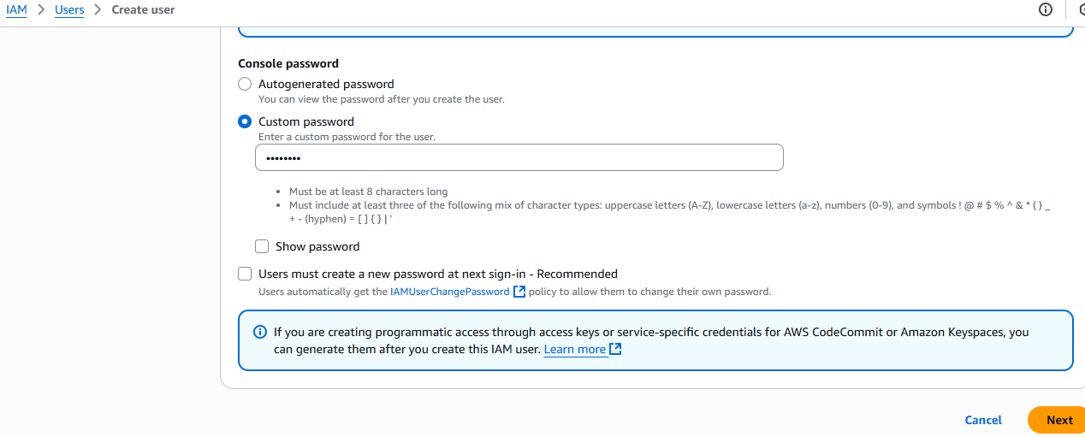

Select **Add user to group** in permission options

Select **techie** in User groups

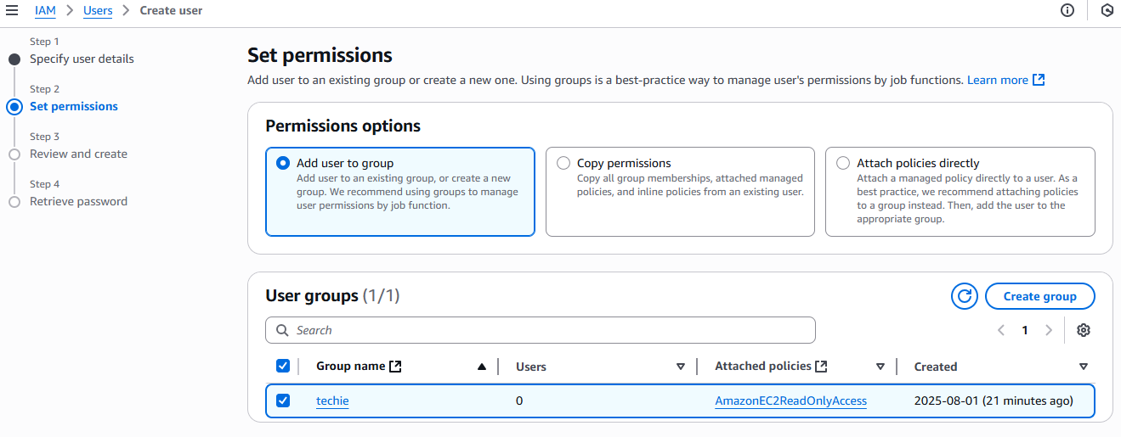

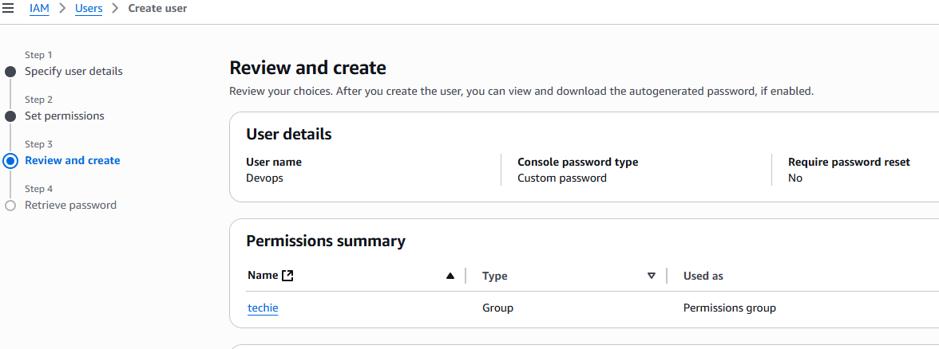

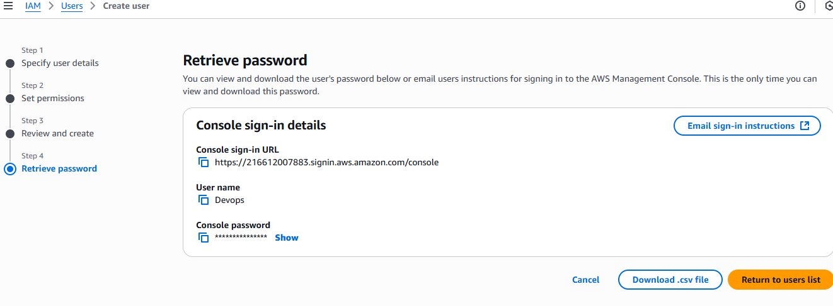

To check the created **Devops** user is added to the **techie** User group

**IAM ---> User groups --->** select created user group **techie**.

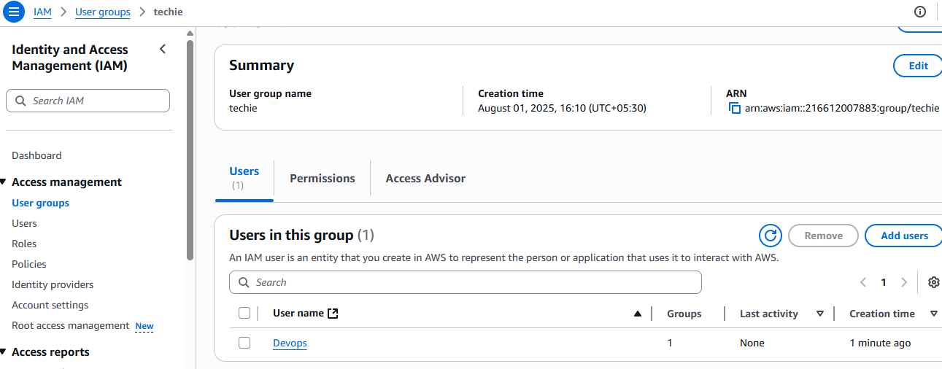

1. **Write a bash script to create a IAM user with VPC full access.**

**EC2 ---> Instance --->** select your instance **---> connect** to instance

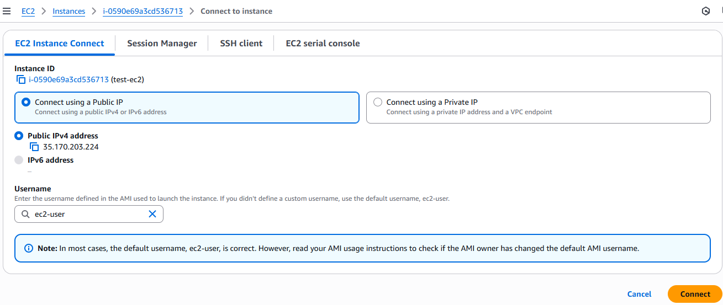

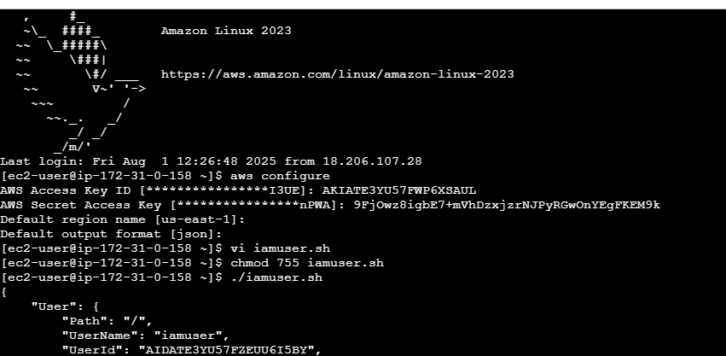

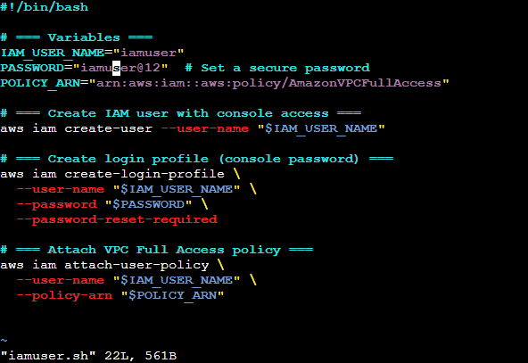

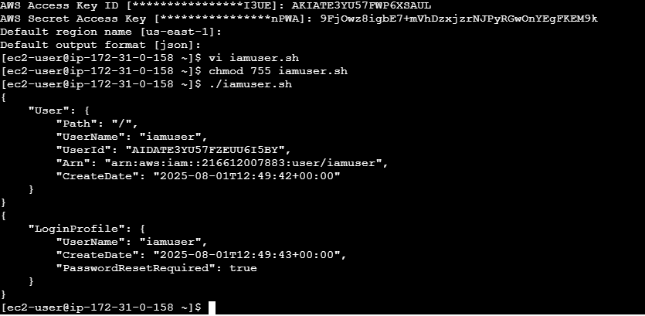

To check created iam user(**iamuser**) with **AmazonEC2FullAccess**

**IAM ---> Users**

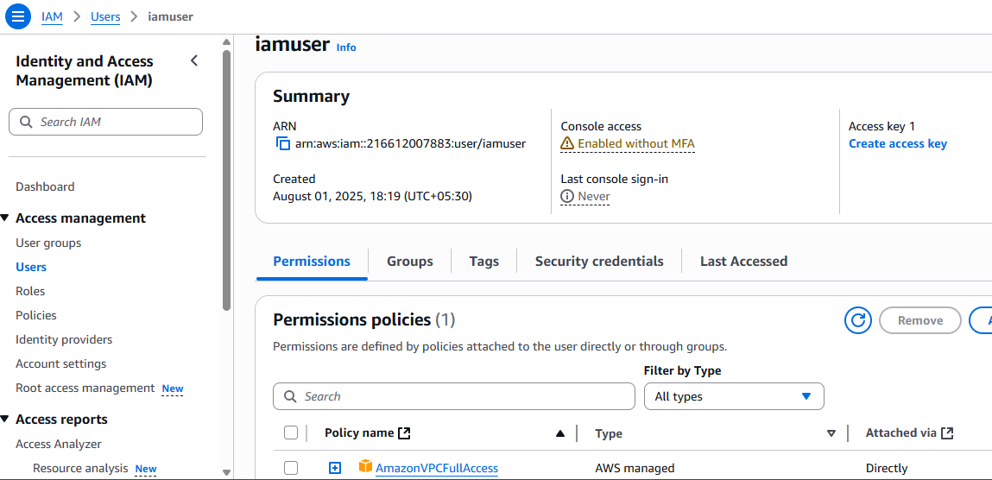

1. **Create a IAM policy to access ec2 for a specific user in specific regions only.**

To creatre policy to access **ec2** in **specific regions.**

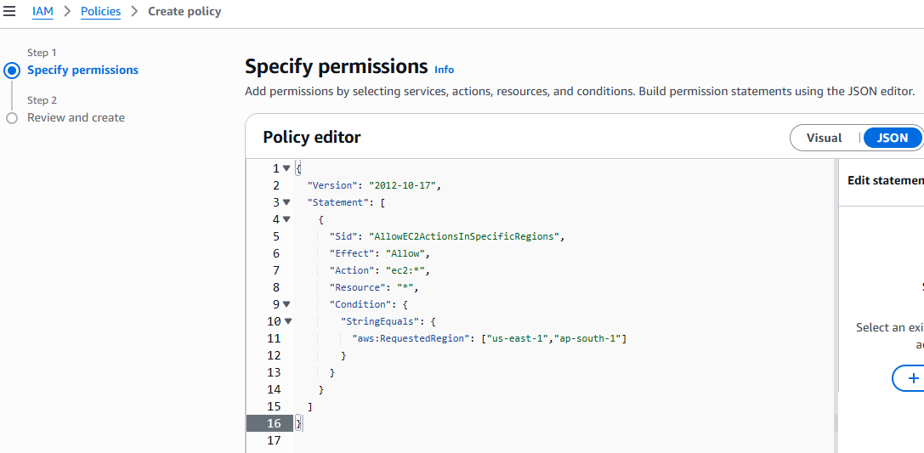

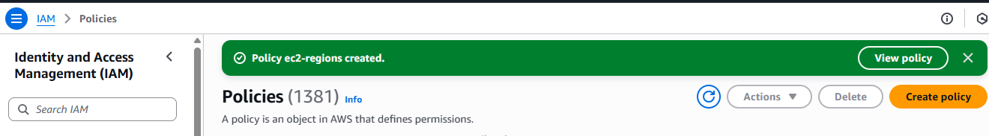

Attach created policy to user

**IAM ---> Users --->** select created user

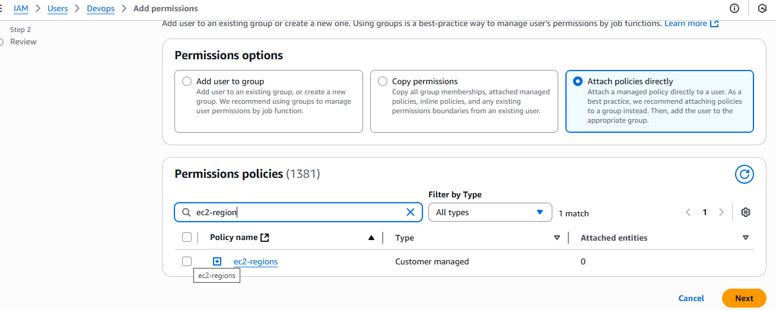

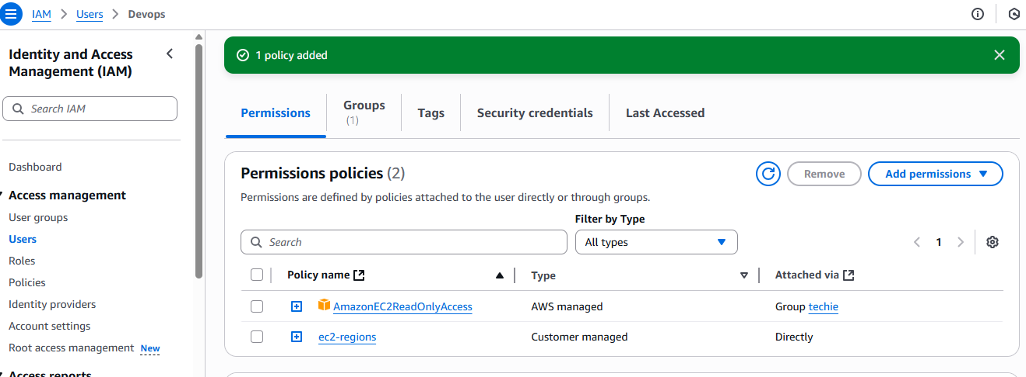

1. **We have two accounts Account A and Account B, Account A user should access s3 bucket in Account B.**

**STEP:1**

**In Account B edit s3 bucket policy**

**S3 ---> Buckets ---> select your bucket ---> permissions --->**

Click **edit** in **Bucket policy**

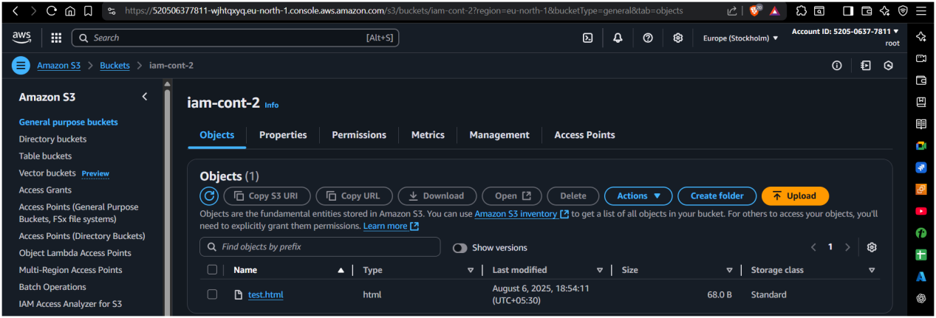

**Add Account A Id and Account B s3 bucket**

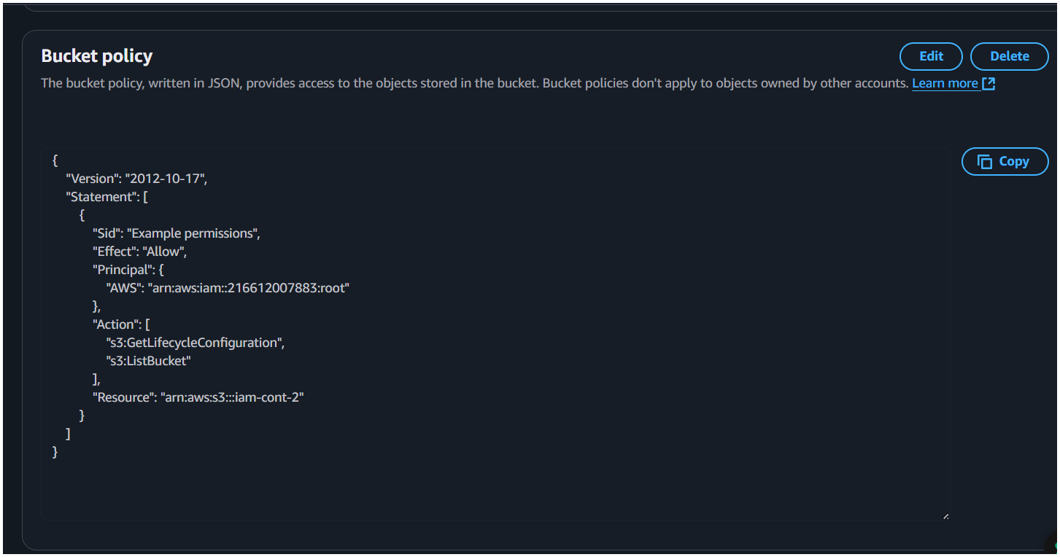

**STEP:2**

**In Account A add Inline policy to Iam user**

**IAM ---> users --->** select your user **---> Permission --->**

Click **add permission --->** select **inline policy**

**Add Account B bucket**

